## Innovative Materials Selection:

### Material Proposed as in PDR:

As in Preliminary Design Report (PDR) of our CANSAT had:

|  |  |  |  |
| --- | --- | --- | --- |
| Serial No. | Component | Previous Material | Modified material |
| 1. | Outer Body Panels | ABS Polycarbonate Sheets | ABS Polycarbonate Sheets |
| 2. | Vertical Rods | 2024 T3 Al Alloy | CFRP Z-100 |
| 3. | Horizontal Bases | 2024 T3 Al Alloy | CFRP Z-100 |
| 4. | Circular Support Rings | -- | CFRP Z-100 |
| 5. | Top Lid | Polyethene Film | Polyethene Film |
| 6. | Parachute & Chords | Ripstop Nylon | Ripstop Nylon |

**Reason to Change Materials:**

* The change in the material of the structure including the Vertical Rods, Horizontal bases and the circular ring support were previously proposed as to be made up of 2024 T3 Al Alloy which is replaced by Carbon Fiber Reinforced Plastic (CFRP) because of the following reasons:

1. **Stress-Strain Curve:**

Lower yield point of the Aluminium in general which would have led to the increase in the deformation as compared to that of the CFRP. Also the ductility as a property in not needed for our use.

1. **Availability:**

Market availability of the Aluminium and it’s alloy is very rare due to the import and export restrictions and also due to the scarcity in the global market and so is not the case with the CFRP Z-100 as the spools, sheets, rods, and plates all are available in the local market.

1. **Economics:**

The cost of Aluminum is too high and cannot fit in the budget constrain of CANSAT whereas cost of CFRP is relatively lower than 2024 T3 Al Alloy.

## Material Acquisition:

* Material for prototype testing was received in early January 2023 but it was sample piece used to validate our own mathematical model as computed.
* Material to be used in the fabrication of the main structure have been ordered and are in process.
* We have received all our electronical components as ordered for the testing and analysis purposes.

## Changes in Mechanical Design Dimensions

|  |  |  |  |  |
| --- | --- | --- | --- | --- |
| **Changes Made** | **Previous Dimensions** | **Previous** | **New Dimensions** | **New** |
| Increased Rod Diameter in Battery and Gyro Compartment | 5 mm |  | 7 mm |  |
| Increased thickness of Base Plate and Parachute 2 Base Plate | 2 mm |  | 5 mm |  |
| Increased Parachute 1 Base Plate thickness | 2 mm |  | 7 mm |  |
| Added a support Plate to increase strength in Parachute 2 Container | 0 mm |  | 5 mm |  |
| Added a hook to grab parachute | - |  | - |  |

# A picture containing handcart Description automatically generatedRectangle Description automatically generatedPhysical layout:

Fig. Home View of CANSAT without body panels

Fig. Home View For CANSAT

Fig. Bottom View of CANSAT

Fig. Top View of CANSAT

# Damping

To deal with the vibration and shock due to thrust of launching vehicle. We have planned of adding up foam and carbon fiber shock dampers to the PCB plates, servo housing, battery setup, camera module and buzzer module.

All the components are a vital part of the CANSAT and for the proper data acquisition all of the components has to be damped against vibration.

Types of Damping Used:

* Shock Absorber for the PCB and Battery plates:

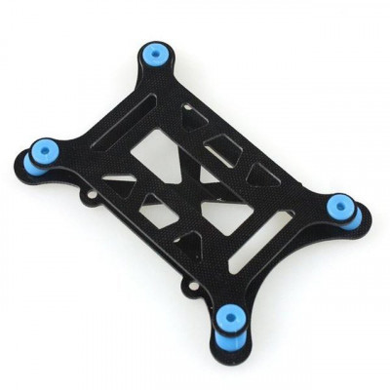

* Shock Absorbing Foam Padding being used for servo motors used for ejection mechanism and gyroscope control:



* 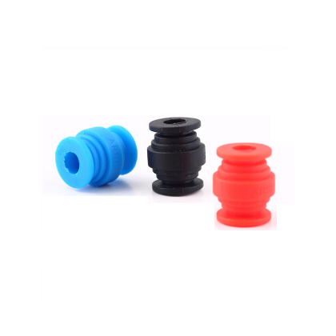Rubber Shock Absorber are being used for the screws which are being used to mount the Outer Body Panel on the CANSAT Frame:

# System Configuration Concepts:

### Selected Design Concept of PDR:

As proposed in the **Preliminary Design Review (PDR)** round held in the September 2022. We have the following design concept proposed:

Fig. Concept 1 Design Proposed

Fig. Concept 1 Design Dimensions

### Design Analysis:

All the below mentioned results were analyzed to simulate the

* Total Deformation:

This is to check deformation along the yaw, pitch & roll caused due to the axial loadings.

* Equivalent stress:

According to the Von-mises Theory, the Equivalent Stress or Von-mises Stress, is most used criteria for checking yield conditions for any structure.

* Stress Intensity:

This is to check the magnitude of the stress generated in a particular component in the CANSAT.

* Shear Stress:

It is the stress generated at the edge of the structure of CANSAT parallel to the vertical axis i.e. the roll axis of the CANSAT.

### CANSAT PDR Proposed Design:-

This is the structure considered for the design analysis of the CANSAT which includes the vertical solid rods and hexagonal plates which all are in a single piece as they are 3-D printed using the Carbon Fibre Spool with a re-inforced packing.

*Fig. Structure considered for the analysis.*

The meshing for the structure is considered of 0.0008 m (meters) with a Path Conforming Tetrahedron mesh elements. The mesh wash fully programme controlled.

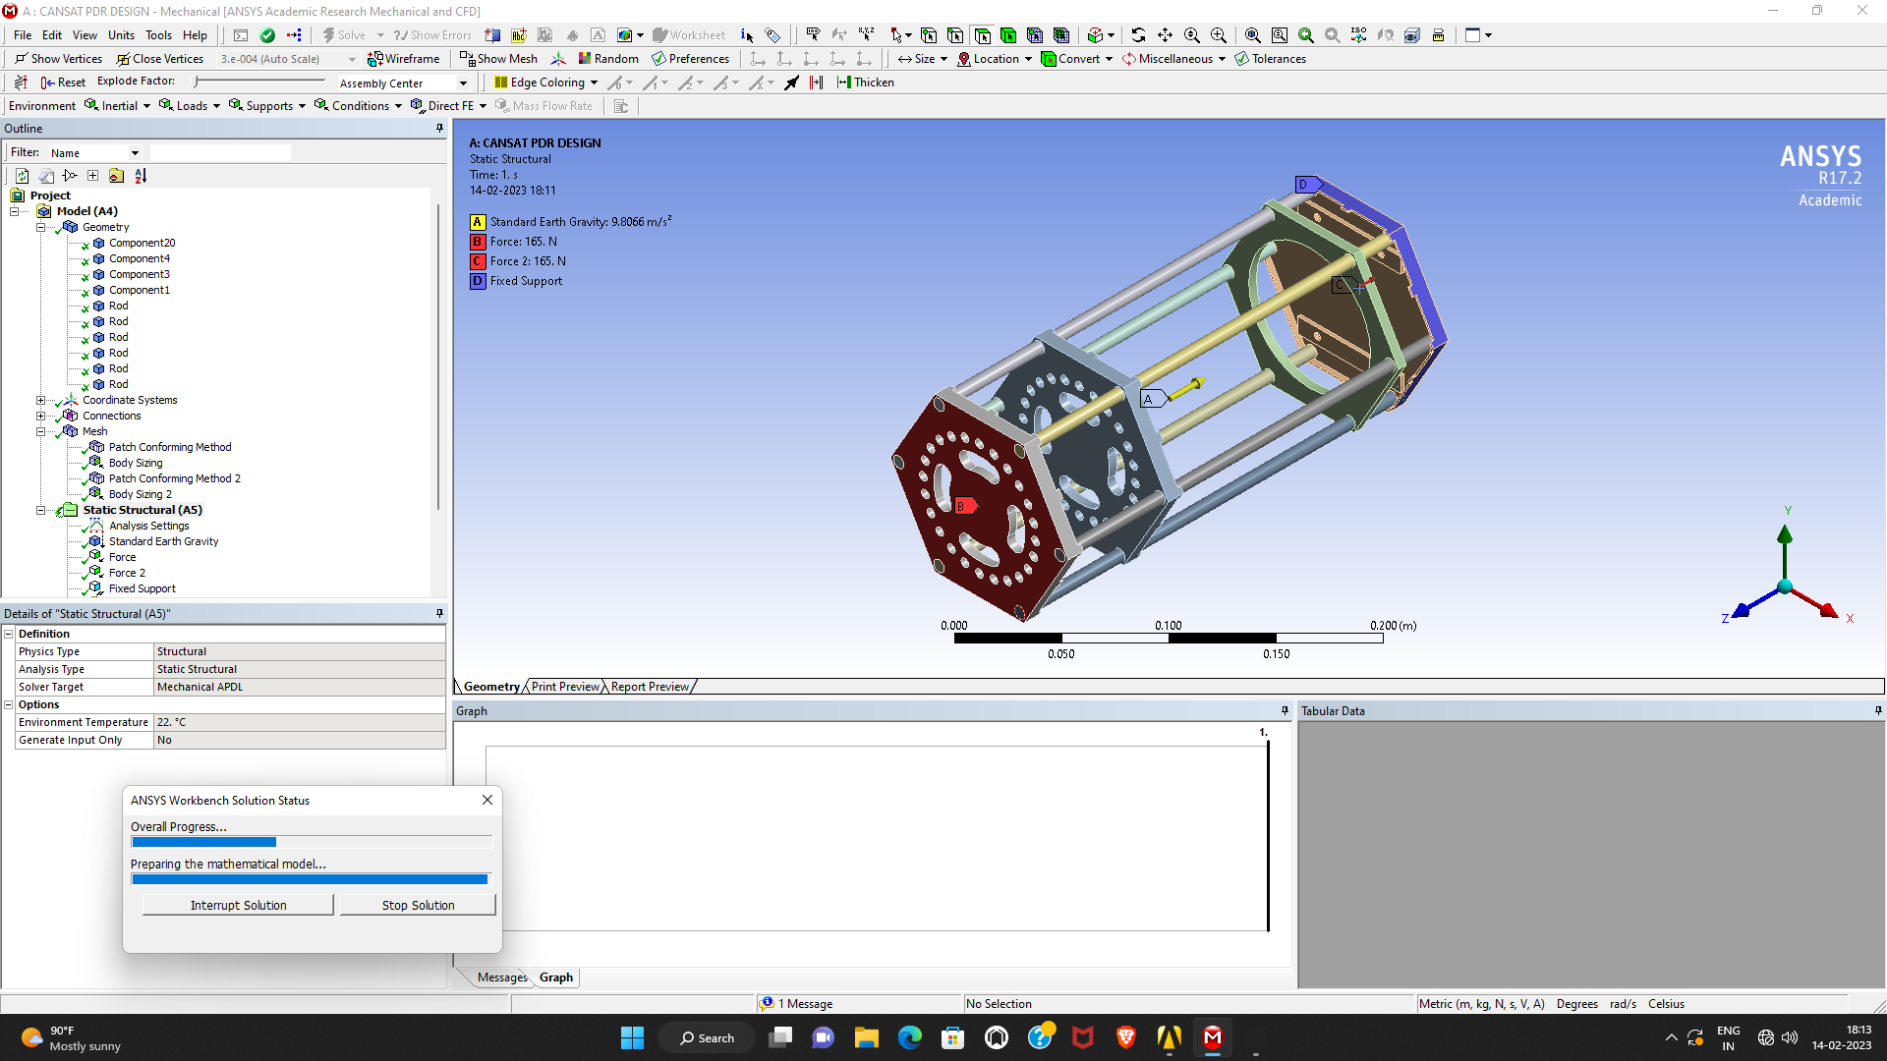The forces are assumed to act in the center of top and bottom plates as the there is a hook in the center of the Top Plate for tying the Parachute Chords to it. Also, we have considered the force due to acceleration of gravity at the center of the CANSAT.

For the same meshed structure, the solution goes as follows:

1. A screenshot of a computer

   Description automatically generated with medium confidenceTotal Deformation:

*Fig. Total Deformation/Distortion in the CANSAT*

1. Equivalent Stress:

*Fig. Window Showing Equivalent Stress in*

1. 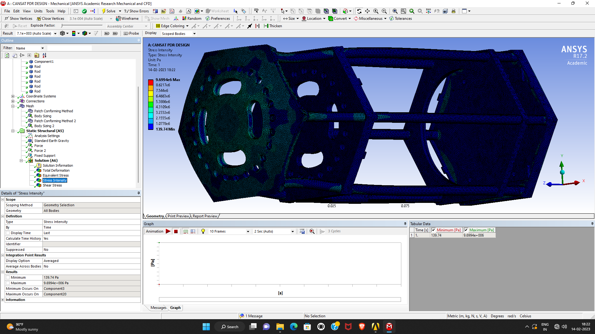Stress Intensity:

*Fig. Stress Intensity in different components of CANSAT*

1. A picture containing text, screenshot, computer, indoor

   Description automatically generatedShear Stress:

*Fig. Shear Stress generated in the CANSAT.*

As it can be seen, the structure has failed the loading of 265 N i.e. the value for 30g’s of launch force and considering the safety and multiplying this by the safety factor of 1.5.

**Observation:**

Looking to the simulation results achieved and as discussed about the change in the material, we have found out that the structure fails if constructed out of normal **Carbon Fiber** spool with this amount of loading.

**Conclusion:**

To avoid any such failure during the launch or ascent we then decided to go with the **Carbon Fiber Reinforced Polymer.** And adding up a extra horizontal support to the structure and replacing the hollow hexagonal faced pipes with the solid circular faced rods.

**Solution Derived:**

For the same three different design versions were prepared and analyzed. The changes to the CANSAT were as follows:

1. Increasing the Diameter of the Vertical Rods
2. Adding Up a circular ring to the compartment deforming
3. Increased Diameter of rods with a circular ring added to the deforming compartment.

Out of all these the 3rd design alteration gave us the best possible results which is as follows:

### CANSAT Improved Design & Analysis:

The design proposed after the alteration is as follows:

The solution to the analysis with the same constraint as of the previous one is as follows:

1. A computer screen capture

   Description automatically generated with medium confidenceTotal Deformation: (Negligible Distortion was observed)

*Fig. No/ Negligible Deformation Observed*

1. A computer screen capture

   Description automatically generated with medium confidenceEquivalent Stress:

*Fig. Reduction In the Equivalent(Von-Mises) Stress of the CANSAT*

1. A computer screen capture

   Description automatically generated with medium confidenceStress Intensity:

*Fig. Reduction in the Stress Intensity generated in the components.*

1. 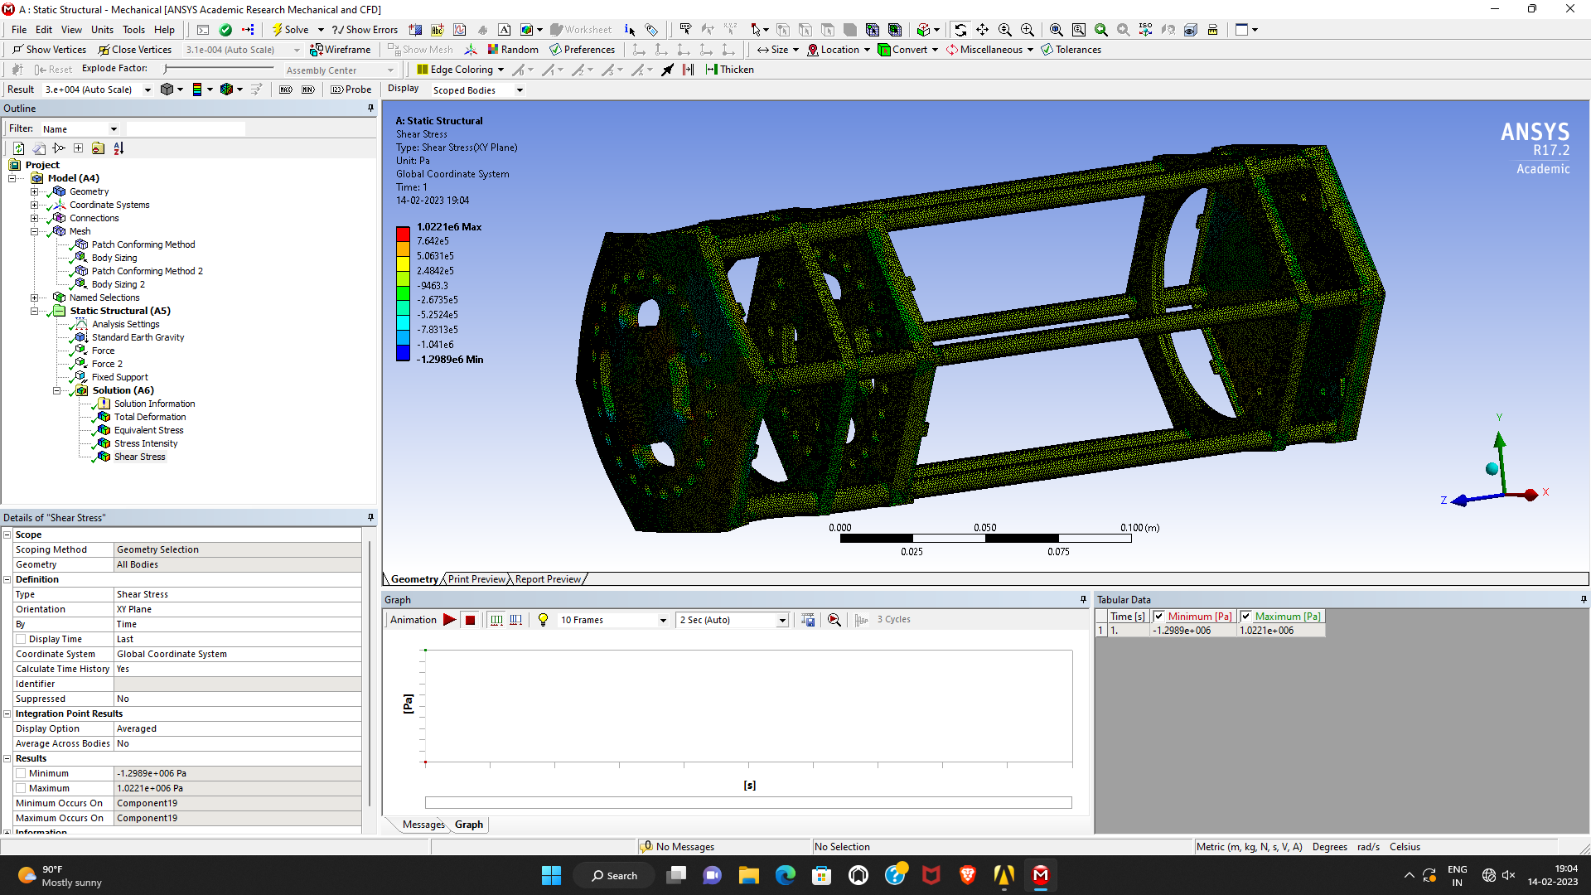Shear Stress:

*Fig. Decrement in the Shear Stresses around the CANSAT*

Conclusion:

Looking to the results observed we hereby consider this particular design of structure of CANSAT to be the best fitted for our purpose.